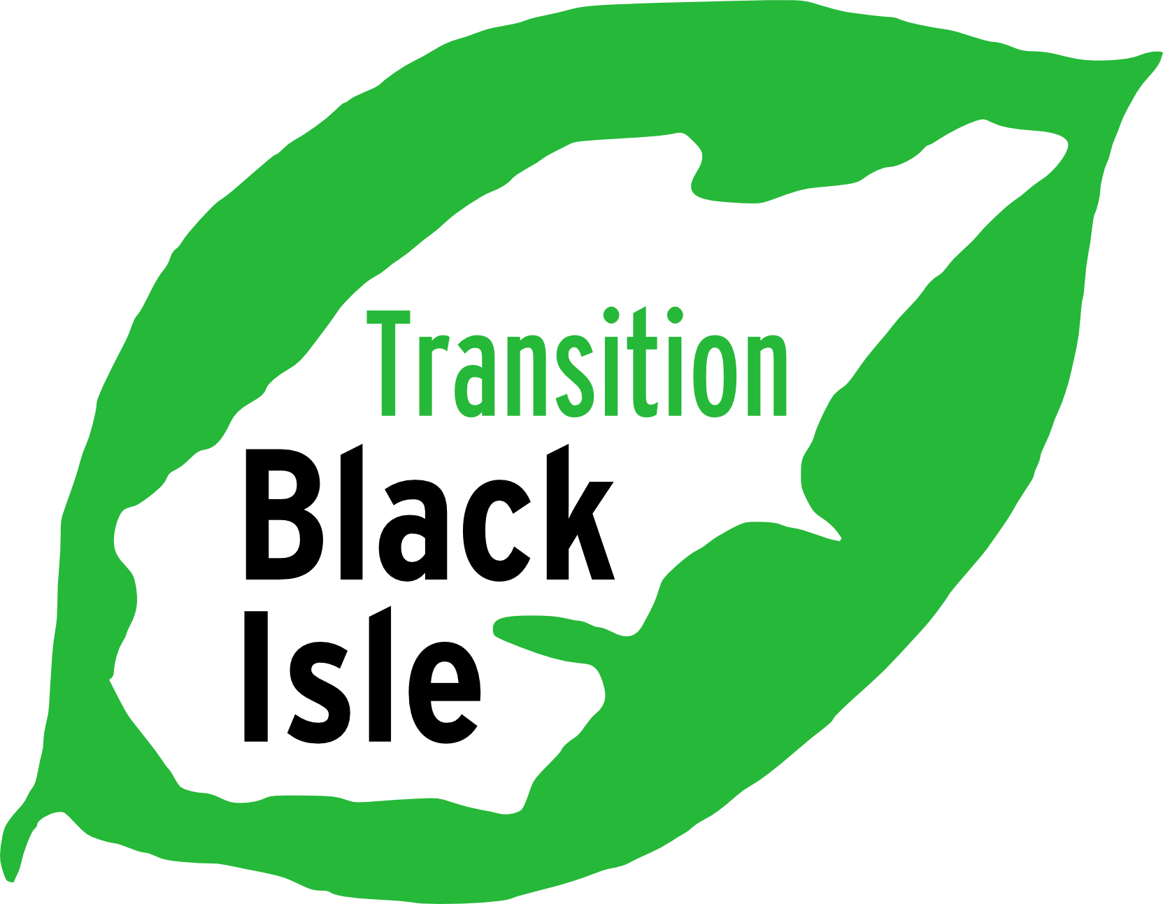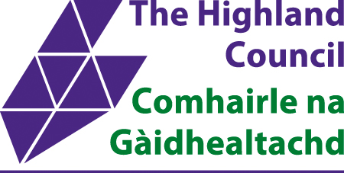Memorandum of Understanding between Highland Council and Transition Black Isle on the development of the Avoch to Munlochy Multi-purpose Path

The following plan was agreed at a meeting on 29 August 2023 between Transition Black Isle (TBI) and Highland Council (THC)

1 Highland Council will be responsible for all deliverables.
2 A regularly scheduled project board will include Lizbeth Collie, Craig Baxter, Neil Young, THC engineer, Anne Thomas, one further unallocated TBI member, Bo Mansell.
3 TBI is happy for an affected landowner or tenant to join the board if The Highland Council so wishes.
4 TBI will chair the board with a standing agenda. The Agenda will cover all deliverables. The Board’s agreement is required on each deliverable. Drafts will be circulated and review by all on board. Relevant standards for design will include Cycling by design / Countryside for all, and others as necessary/appropriate.
5 Any third party contribution to the board or attendance at meeting needs to be agreed with the chair in advance.
6 Board meetings will not go ahead without a board member representing THC present.

Signed for TBI by Anne Thomas, lead TBI member on the Multi-purpose path

Date

Signed by THC by

Date

